job - is set of commands that we want to execute. Or it is the task that we want to automate.

Эти джобы могут быть разного вида

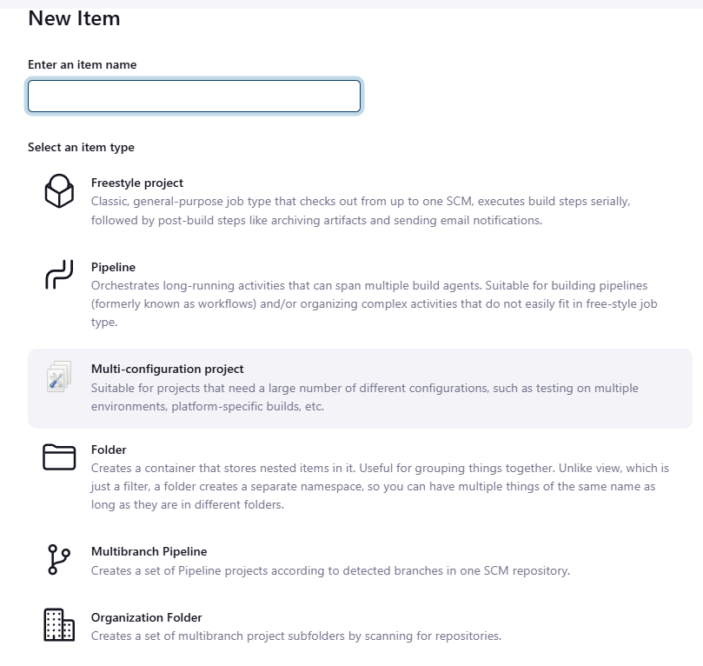

или

Whatever the task we want to do via Jenkins it is a Jenkins job. We might create n number of job.

If you know how to execute the command via cmd, Jenkins can do it for you.

To create job click + sign, enter a name, choose the type.

For example:

let's use Freestyle project, click build steps → choose execute shell →enter the instruction in the field → save.

Go to Dashboard, you should see the job presented, click on it, choose 'Build now'. After its done, click on the

result and choose Console output in order to see the logs.